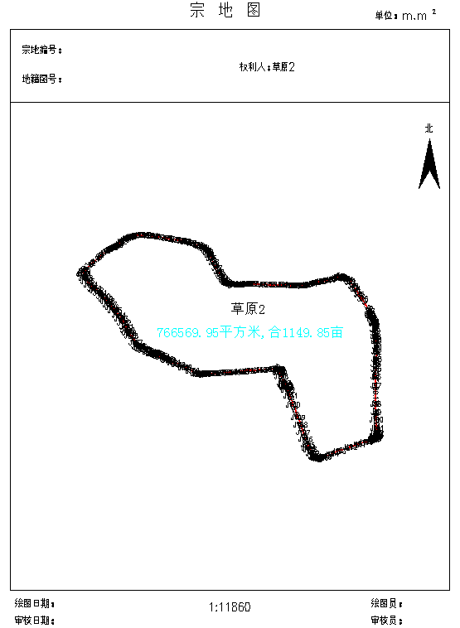

界 址 点 成 果 表 |  |  |  | 第 1 页
 |  |  |  | 共 6 页
宗地号: 111112
权利人: 1
宗地面积(平方米): 766569.950
建筑面积(平方米): 0.000
界 址 点 坐 标
序 号 | 点 号 | 坐 标 |  | 边 长
序 号 | 点 号 | x(m) | y(m) | 边 长
1 | J1 | 5185217.515 | 42483859.46
 |  |  |  | 45.334
2 | J2 | 5185248.571 | 42483892.48 | 45.334
 |  |  |  | 46.205
3 | J3 | 5185279.108 | 42483927.16 | 46.205
 |  |  |  | 13.827
4 | J4 | 5185288.483 | 42483937.32 | 13.827
 |  |  |  | 37.724
5 | J5 | 5185310.543 | 42483967.93 | 37.724
 |  |  |  | 16.132
6 | J6 | 5185318.929 | 42483981.71 | 16.132
 |  |  |  | 13.585
7 | J7 | 5185325.34 | 42483993.68 | 13.585
 |  |  |  | 12.036
8 | J8 | 5185330.273 | 42484004.66 | 12.036
 |  |  |  | 11.242
9 | J9 | 5185334.606 | 42484015.04 | 11.242
 |  |  |  | 3.832
10 | J10 | 5185336.433 | 42484018.4 | 3.832
 |  |  |  | 6.288
11 | J11 | 5185341.372 | 42484022.29 | 6.288
 |  |  |  | 18.606
12 | J12 | 5185354.235 | 42484035.74 | 18.606
 |  |  |  | 17.708
13 | J13 | 5185363.236 | 42484050.99 | 17.708
 |  |  |  | 12.899
14 | J14 | 5185368.874 | 42484062.59 | 12.899
 |  |  |  | 14.559
15 | J15 | 5185375.115 | 42484075.74 | 14.559
 |  |  |  | 8.077
16 | J16 | 5185377.749 | 42484083.38 | 8.077
 |  |  |  | 19.022
17 | J17 | 5185381.992 | 42484101.92 | 19.022
 |  |  |  | 22.773
18 | J18 | 5185384.894 | 42484124.51 | 22.773
 |  |  |  | 18.554
19 | J19 | 5185385.199 | 42484143.06 | 18.554
 |  |  |  | 23.756
20 | J20 | 5185383.496 | 42484166.75 | 23.756
 |  |  |  | 21.104
21 | J21 | 5185382.335 | 42484187.83 | 21.104
 |  |  |  | 33.591
22 | J22 | 5185376.3 | 42484220.87 | 33.591
 |  |  |  | 37.55
23 | J23 | 5185369.707 | 42484257.84 | 37.55
 |  |  |  | 45.031
24 | J24 | 5185363.418 | 42484302.43 | 45.031
 |  |  |  | 27.436
25 | J25 | 5185358.247 | 42484329.37 | 27.436
 |  |  |  | 19.346
26 | J26 | 5185354.376 | 42484348.33 | 19.346
 |  |  |  | 28.656
27 | J27 | 5185347.494 | 42484376.14 | 28.656
 |  |  |  | 32.285
28 | J28 | 5185337.27 | 42484406.77 | 32.285
 |  |  |  | 11.869
29 | J29 | 5185332.544 | 42484417.65 | 11.869
 |  |  |  | 12.237
30 | J30 | 5185327.524 | 42484428.81 | 12.237
 |  |  |  | 12.366
31 | J31 | 5185320.484 | 42484438.98 | 12.366
 |  |  |  | 13.412
32 | J32 | 5185311.636 | 42484449.06 | 13.412
 |  |  |  | 12.819
33 | J33 | 5185301.594 | 42484457.03 | 12.819
 |  |  |  | 14.21
34 | J34 | 5185289.574 | 42484464.61 | 14.21
 |  |  |  | 19.017
35 | J35 | 5185272.566 | 42484473.11 | 19.017
 |  |  |  | 20.681
36 | J36 | 5185254.598 | 42484483.35 | 20.681
制表: 校审: 2024年8月20日

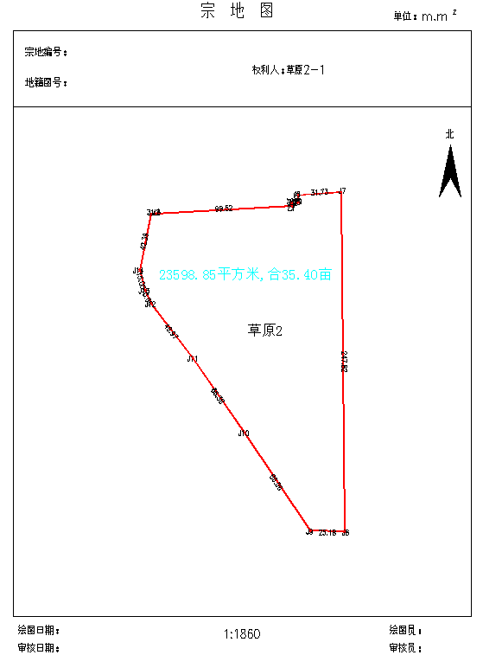

界 址 点 成 果 表 |  |  |  | 第 1 页
 |  |  |  | 共 1 页
宗地号: 111113
权利人: 1
宗地面积(平方米): 23598.854
建筑面积(平方米): 0.000
界 址 点 坐 标
序 号 | 点 号 | 坐 标 |  | 边 长
序 号 | 点 号 | x(m) | y(m) | 边 长
1 | J1 | 5185259.412 | 42485136.01
 |  |  |  | 3.481
2 | J2 | 5185259.554 | 42485139.49 | 3.481
 |  |  |  | 99.517
3 | J3 | 5185264.853 | 42485238.87 | 99.517
 |  |  |  | 2.229
4 | J4 | 5185267.079 | 42485238.75 | 2.229
 |  |  |  | 4.804
5 | J5 | 5185267.336 | 42485243.55 | 4.804
 |  |  |  | 5.553
6 | J6 | 5185272.881 | 42485243.24 | 5.553
 |  |  |  | 31.732
7 | J7 | 5185275.084 | 42485274.9 | 31.732
 |  |  |  | 247.815
8 | J8 | 5185027.28 | 42485277.28 | 247.815
 |  |  |  | 25.176
9 | J9 | 5185028.038 | 42485252.12 | 25.176
 |  |  |  | 86.063
10 | J10 | 5185099.64 | 42485204.37 | 86.063
 |  |  |  | 66.378
11 | J11 | 5185154.15 | 42485166.49 | 66.378
 |  |  |  | 49.97
12 | J12 | 5185193.756 | 42485136.02 | 49.97
 |  |  |  | 10.596
13 | J13 | 5185203.401 | 42485131.63 | 10.596
 |  |  |  | 15.048
14 | J14 | 5185217.882 | 42485127.54 | 15.048
 |  |  |  | 42.385
1 | J1 | 5185259.412 | 42485136.01 | 42.385

制表: 校审: 2024年8月20日

